Data
23 February 2026
09:43

What is Data?
Data is the raw form of information, a collection of facts, figures, symbols or observations that represent details about events, objects or phenomena.
It can be anything that helps us understand, decide, or learn something.
For example:
  - Your age → data
  - A photo → data
  - A temperature reading → data
  - A message you send → data
So, data = facts or information that we collect.

Types of Data
  - Qualitative Data (Descriptive Data)
This is data that describes qualities, characteristics, or words.
It cannot be measured, only described.
Examples:
  - Colors (red, blue, green)
  - Feelings (happy, sad)
  - Names (Krish, Rahul)
  - Types of food (sweet, spicy)
Think of it as:
“Data that tells us what something is like.”

  - Quantitative Data (Numeric Data)
This is data that can be measured and written in numbers.
Examples:
  - Age: 20 years
  - Height: 170 cm
  - Marks: 85/100
  - Temperature: 30°C
Think of it as:
“Data that tells us how much or how many.”
Types of Quantitative Data
Within numeric data, there are 2 types:
a) Discrete Data
  - Whole numbers
  - You count them
  - No decimals
Examples:
  - Number of students in a class (35)
  - Number of cars (10)
b) Continuous Data
  - Can have decimals
  - You measure them
Examples:
  - Height (172.5 cm)
  - Weight (65.8 kg)
  - Time (3.75 seconds)

  - Structured Data
Data that is highly organized, stored in rows and columns (like an Excel sheet or a database) that makes it easily searchable and manageable by traditional databases
Easy example
Name | Age | City
Krish | 20 | Pune
Characteristics
  - Very organized
  - Easy to search, filter, analyze
  - Fixed format
Examples
  - Banking records
  - Employee database
  - Excel sheets
  - SQL database tables
Think: “Data that fits perfectly into a table.”

  - Unstructured Data
Data that has no fixed structure. It cannot be stored in rows and columns.
Examples
  - Images
  - Videos
  - Audio files
  - PDFs
  - Emails (the body text)
Characteristics
  - Messy/Free format
  - Harder to analyze
Think: “Data everywhere with no clear arrangement.”

  - Semi-structured Data
Data that is partially organized — it doesn’t fit into tables, but it still has some structure using tags.
Examples
  - JSON files
  - XML files
  - HTML
  - Emails (subject, sender → structured; message body → unstructured)
Example (JSON)
{
"name": "Krish",
"age": 20,
"skills": ["Python", "SQL"]
}
Characteristics
  - Some organization
  - Easier than unstructured, but not as organized as structured
  - Flexible format
Think: “Data in boxes with labels, but inside the box things can be random.”

Summary Table
Type | Structure | Examples | Difficulty to Analyze
Structured | Highly organized | SQL tables, Excel | ⭐ Easy
Semi-structured | Partially organized | JSON, XML, HTML | ⭐⭐ Medium
Unstructured | No structure | Videos, Photos, PDFs | ⭐⭐⭐ Hard
Big Data
When datasets grow in size, complexity and speed, traditional methods don’t suffice. Big Data refers to datasets that are too large, too varied or too fast to be handled by traditional data processing tools.
The defining characteristics often called the Vs of Big Data are:
  - Volume: Massive amounts of data.
  - Velocity: Speed of generation and processing.
  - Variety: Different formats: structured, unstructured, semi-structured.
  - Veracity: Accuracy, trustworthiness of data to deal with noise and errors.
  - Value: The usefulness of data i.e having data is not enough, we must extract value from data.

Sources of Data

Source of Data | Type of Data | Description | Stored In (Form / Format) | Practical Examples
Surveys | Structured / Semi-structured | Data collected through questionnaires with predefined questions | CSV, Excel (.xlsx), JSON, Google Sheets | Google Forms customer satisfaction survey, NPS survey(Net Promoter Score) - Customer Loyalty and Satisfaction, employee engagement survey
Interviews | Unstructured / Semi-structured | Verbal or written responses collected through conversations | Audio files (.mp3, .wav), Text transcripts (.txt, .docx), PDFs | Job interview recordings, market research interviews, expert panel discussions
Observations | Unstructured | Data collected by watching and recording behaviours or events | Text files, Excel sheets, Field notes (PDF), CSV | Counting customers entering a mall, observing classroom participation, monitoring factory workflow
Experiments | Structured | Data from controlled scientific or industrial experiments | CSV, Excel, SQL tables, Lab system databases | clinical drug trial results, product durability testing
Transactional Systems | Structured | Data produced during business operations | Relational databases (MySQL, PostgreSQL), CSV exports | Amazon order records, bank ATM transactions, POS billing data
Sensors & IoT Devices | Structured / Semi-structured | Machine-generated data from sensors and devices | JSON streams, Time-series DB, CSV, Parquet | Smartwatch heart-rate data, temperature sensors in cold storage, smart home motion detectors
Social Media | Unstructured | Free-form content generated by users online | JSON, NoSQL databases (MongoDB), API responses | Twitter posts, Instagram comments, YouTube reviews, LinkedIn posts
Logs & Machine Data | Semi-structured | System-generated logs capturing events or activities | Log files (.log), JSON, XML | Web server logs, application error logs, firewall security logs
Documents | Unstructured | Text-heavy files without fixed format | PDF, DOCX, TXT | PDF reports, legal contracts, research papers, Word documents
Multimedia | Unstructured | Audio, video, and image data | JPEG, PNG, MP4, AVI, MP3 | CCTV footage, podcast recordings, product photos, medical X-ray images
Web Pages | Semi-structured | Data with markup tags but not fixed tables | HTML, XML | HTML product pages, blog articles, news websites
Emails | Semi-structured / Unstructured | Semi-structured metadata, unstructured message body | EML files, Database storage | Customer support emails, marketing newsletters, internal communication emails
Databases | Structured | Highly organized data stored in tables | SQL tables (rows & columns) | MySQL customer database, PostgreSQL ERP system, Oracle financial database
Data Warehouses | Structured | Large, organized stores of historical data | Columnar formats (Parquet, ORC), SQL tables | Snowflake warehouse, enterprise BI reporting system, corporate analytics database
Open Data Sources | Mixed | Publicly available datasets | CSV, JSON, XML, APIs, Excel | Government census data, World Bank datasets, Kaggle datasets, research repositories

Clusters
23 February 2026
10:30
What Are Clusters in Databricks? (Simple Explanation)
A cluster in Databricks is just a group of virtual machines (computers in the cloud) that work together to run your code—mainly Spark or PySpark.
Think of it like this:
You write code → Cluster executes it.
Clusters help you run:
- ETL pipelines
- Machine learning models
- Streaming jobs
- Batch jobs
- Ad-hoc analysis in notebooks

1. Types of Clusters in Databricks
Databricks has two main types of clusters:
- Interactive / All-Purpose Clusters
Used for:
- Exploring data
- Running notebooks
- Working collaboratively with others
Key points:
- You start/stop these manually.
- Multiple users can share them.
- Great for development, testing, learning, experimenting.
Example 1: Data Exploration
You are a data analyst and you want to check last month’s sales data.
You start an interactive cluster, open your notebook, run queries, test some ideas, maybe fix some errors, and explore different columns.
Example 2: Learning or Training
You are learning PySpark.
You create a cluster, try different commands, break things, fix them, test joins, test aggregations.
Example 3: Team Collaboration
Three team members are working on the same project.
They all attach their notebooks to the same cluster and work together.
- Job Clusters
Used for:
- Automated scheduled jobs
- Production pipelines
Key points:
- Automatically created when a job starts.
- Automatically deleted when the job ends.
- Cannot be restarted.
- More cost-efficient for production workloads
Example 1: Daily Report
Every day at 2:00 AM, your company generates a sales report automatically.
Databricks creates a job cluster at 2:00 AM.
It runs the pipeline.
Once the report is generated, the cluster shuts down automatically.
Example 2: Weekly Data Pipeline
Every Sunday night, raw data is cleaned and moved to a final table.
The job starts.
A new cluster is created just for that job.
When the job finishes, the cluster is deleted.
2. Cluster Modes in Databricks
Databricks supports 3 cluster modes.
You choose one when creating a cluster.
Once a cluster is created, you cannot change its mode.
2.1 Standard Mode (No Isolation Shared Mode)
- Multiple users can access the cluster.
- No isolation → all users share resources directly.
- Supports: Python, SQL, R, Scala
- Good for:
  - Individuals
  - Small teams
  - Normal workloads
Automatically shuts down after 120 mins (default).
Think of it as: A shared office with desks. Everyone can work together, but all share the same space and resources.
Example 1: Internship Team Working on Notebooks
A group of 3 interns (Krish, Ravi, Priya) are running notebooks for learning Spark.
- They run Python, SQL, and Scala freely.
- Sometimes one intern runs a heavy job that slows down others.
- It’s fine because the workload is small.
Example 2: Small Data Engineering Team
A small team does daily testing on a shared cluster.
- They run ETL scripts.
- Workloads are not heavy.
- Occasional conflicts are acceptable.

2.2 High Concurrency Mode (Shared Access Mode)
This is a more advanced cluster mode.
Features:
- Cloud-managed, highly optimized, fast.
- Best resource sharing across users.
- Lower query latencies.
- Supports Table Access Control → Better security.
  - Table Access Control (TAC) is a security feature in Databricks that controls who can access which tables, views, and databases, and what they can do with them (SELECT, INSERT, UPDATE, etc.).
Language support:
- Supports: Python, SQL, R
- Does not support Scala
(because Scala doesn’t isolate user code the way the cluster requires)
Scala runs directly on the Spark driver and executor JVM.
That means it can:
- Access SparkContext directly
- Read raw files using spark.sparkContext
- Access DBFS paths directly
- Potentially bypass SQL permission checks
Usage:
- Ideal for production data analytics.
- Best for SQL-heavy workloads.
- Very secure for multi-user scenarios.
Does not shut down automatically by default.
Think of it as: A cafeteria in a company. Many people can use it at once, and it's optimized to handle crowds.
Example 1: Company-Wide SQL Dashboard Queries
Dozens of analysts run SQL queries for dashboards like Power BI or Tableau.
- Queries must run fast.
- Security (Table Access Control) is important.
- Users should not affect each other’s workloads.

2.3 Single Node Clusters
As the name says:
- Only one machine (only driver node)
- No worker nodes
Used for:
- Small datasets
- Single-machine ML workloads
- Lightweight notebooks
It still runs Spark, but on one machine.
Automatically terminates after 120 mins (default).
Think of it as: Your personal laptop on the cloud. Only one person, one machine, simple workloads.
Example 1: Testing a Small Machine Learning Model
You wants to test a small ML model on a CSV file (5 MB).
- No need for distributed processing
- Only Python code
- Runs everything on a single machine
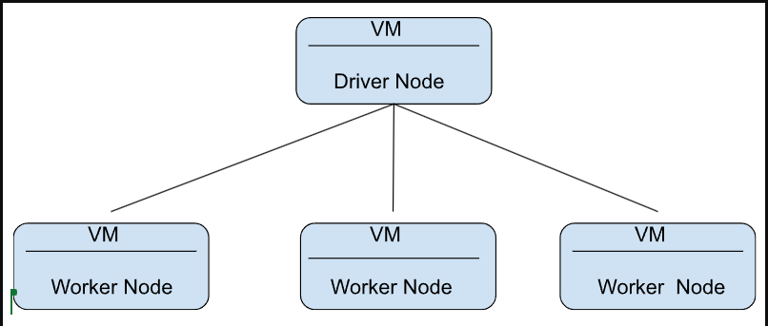
3. Conclusion (Very Simple Summary)
Cluster Mode | Best For | Languages | Key Notes
Standard | Normal workloads, developers | Python, SQL, R, Scala | No isolation; auto-terminate
High Concurrency | Production, multi-user, secure SQL workloads | Python, SQL, R | No Scala; secure; doesn’t auto-terminate
Single Node | Small data, ML, testing | All languages | Only one node
Types of clusters:
- ✔ All-purpose cluster → For notebooks & exploration
- ✔ Job cluster → For automated jobs

Real-Time Processing and Batch Processing
23 February 2026
13:50

What is Batch Processing?
Simple Definition
Batch processing means:
Processing a large amount of stored data all at once, after it has been collected.
You don’t process data immediately.
You collect it first → then process it later.

Simple Example
Imagine a supermarket:
- All sales of the day are stored.
- At midnight, the system calculates:
  - Total sales
  - Total profit
  - Inventory update
That midnight job = Batch Processing

Real-World Examples
- Monthly salary processing
- Daily sales reports
- End-of-day bank reconciliation
- Generating weekly analytics dashboards
- Historical data analysis

How It Works (Technically)
- Data is collected and stored (HDFS, S3, DB)
- A job runs at a scheduled time
- It processes large volumes of data
- Output is stored
Usually runs:
- Every hour
- Every day
- Every week

Hadoop is Designed For This
Hadoop MapReduce:
- Reads large stored datasets
- Processes them
- Writes output back
- High latency is acceptable

What is Real-Time Streaming?
Simple Definition
Real-time streaming means:
Processing data immediately as it is generated.
No waiting.
Data comes → process instantly → produce result.

Simple Example
Imagine a credit card transaction:
- You swipe your card.
- Within 1–2 seconds:
  - Fraud detection runs
  - Transaction approved or declined
That is real-time streaming.

Real-World Examples
- Fraud detection
- Stock price monitoring
- Live website click tracking
- Uber ride tracking
- Social media sentiment analysis
- IoT sensor monitoring

How It Works (Technically)
- Data flows continuously
- System processes small chunks immediately
- Results are updated continuously
Data never “stops” — it keeps flowing.

Key Difference
Feature | Batch Processing | Real-Time Streaming
Data | Stored first | Processed immediately
Speed | Slower | Very fast
Latency | Minutes to hours | Milliseconds to seconds
Use Case | Reports | Alerts / Live dashboards
Example | Monthly report | Fraud detection

Timeline Visualization
Batch Processing
Collect Data → Store → Process Later → Output
Example:
All day data → Process at night

Real-Time Streaming
Data Arrives → Process Immediately → Output
Data Arrives → Process Immediately → Output
Data Arrives → Process Immediately → Output
Continuous pipeline.

Micro-Batch (Important Concept)
Some systems (like Spark Streaming) use:
Micro-batching
It means:
- Collect data for 1–5 seconds
- Process that small chunk
- Repeat continuously
So it looks real-time, but technically processes tiny batches.

When to Use What?
Use Batch When:
- Time is not critical
- Large historical data
- Cost needs to be lower
- Reporting/analytics workload
Use Real-Time When:
- Immediate action required
- Fraud detection
- Monitoring systems
- Live dashboards

Interview-Level Answer
If interviewer asks:
Batch processing handles large volumes of accumulated data at scheduled intervals, while real-time streaming processes data immediately as it is generated with very low latency.

Simple One-Line Memory Trick
Batch = “Process Later”
Streaming = “Process Now”

Distributed Computing
18 February 2026
15:39

Process of splitting a large computing task into smaller subtasks and executing them in parallel across multiple machines that work together as a single system.

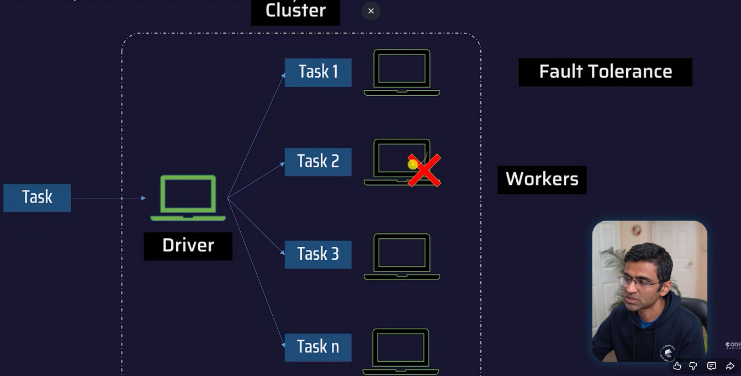

Apache Hadoop
Apache Hadoop is a distributed processing framework of large data sets across clusters of computers.
- Hadoop was disk heavy and slow

Apache Spark
Open-source, distributed computing engine designed to process large-scale data quickly and efficiently.
- A distributed computing engine that abstracts(hides) the complexity of parallelism, letting developers focus on business logic.

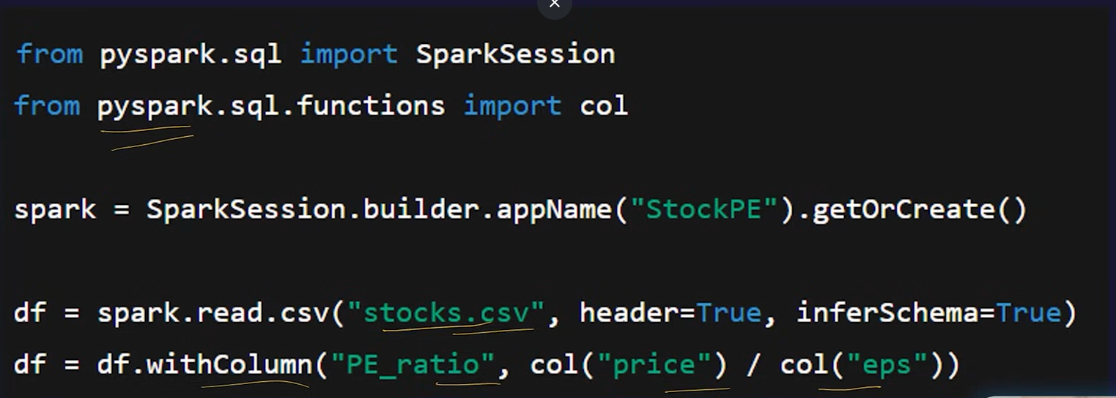

Ways to Run Apache Spark

Apache Hadoop vs Apache Spark
23 February 2026
11:16
- Why Spark Was Created
When Apache Hadoop was created (around 2006), the main goal was:
“How can we process massive data across many cheap computers?”
It solved that problem very well.
But over time, new problems appeared:
- Companies wanted real-time analytics
- Machine learning became important
- Interactive SQL queries were needed
- Iterative algorithms (ML, graph processing) were too slow in Hadoop
Hadoop MapReduce was:
- Disk-based
- Batch-only
- Not optimized for iterative workloads
So Spark was designed to fix these limitations.

- Core Architectural Difference
Apache Hadoop Architecture
Main components:
- HDFS → Storage layer
- YARN → Resource manager
- MapReduce → Processing engine
How Hadoop Processes Data
- Read data from disk (HDFS)
- Process (Map step)
- Write intermediate result to disk
- Read again from disk
- Process (Reduce step)
- Write back to disk
Every stage → disk I/O
Disk I/O is slow
That causes high latency
Hadoop is designed for:
- Large batch jobs
- High fault tolerance
- Cheap scaling

Apache Spark Architecture
How Spark Processes Data
- Load data into memory (RAM)
- Process in memory
- Reuse data for multiple operations
- Write to disk only when needed
Key concept: Resilient Distributed Dataset (RDD)
RDD:
- Distributed
- Immutable
- Fault tolerant
- Keeps lineage (remembers how it was built)
Instead of writing intermediate results to disk, Spark keeps them in memory.
That’s the biggest architectural difference.

- Storage Layer Difference
Hadoop | Spark
Has its own storage (HDFS) | No native storage
Strong distributed file system | Uses external storage
Designed for storage + compute | Designed mainly for compute
Spark can run on:
- HDFS
- Amazon S3
- Redshift
- Azure Data Lake
- Local storage
Very often:
Hadoop = Storage
Spark = Processing

- Performance Comparison
Hadoop Performance
- Disk-based
- Each stage writes to disk
- Slower for multi-step jobs
- Not suitable for interactive queries
Best for:
- Large batch processing
- Monthly reports
- Historical data analysis

Spark Performance
- In-memory computing
- Optimized execution engine
- DAG-based(Directed-Acyclic Graph) execution (not just Map → Reduce)
Spark builds a Directed Acyclic Graph (DAG) of operations.
This allows:
- Optimization before execution
- Fewer disk writes
- Smarter execution planning
Spark can be:
- 10x to 100x faster (depending on workload)
Especially fast for:
- Iterative algorithms
- Machine learning
- Streaming
- Interactive SQL

- Batch vs Real-Time
Type | Hadoop | Spark
Batch Processing | Yes | Yes
Real-time Streaming | No | Yes
Interactive Queries | Very slow | Fast
Event Processing | Not ideal | Designed for it
Example:
- Monthly sales report → Hadoop is fine
- Fraud detection in live transactions → Spark is better

- Machine Learning Capabilities
Hadoop
- No built-in ML engine
- Needs external tools like Apache Mahout
- Complex setup
Spark
- Built-in ML library → MLlib
- Supports:
  - Regression
  - Classification
  - Clustering
  - Recommendation systems
- Works on distributed data
- Faster because of in-memory processing
This made Spark extremely popular in Data Science.

- Fault Tolerance (How They Handle Failure)
Both are fault tolerant — but differently.
Hadoop
- Replicates data blocks (default 3 copies)
- If one node fails → use another copy
Storage-based fault tolerance

Spark
- Uses RDD lineage
- Remembers how data was computed
- If partition is lost → recompute it
Computation-based fault tolerance

- Scalability
Hadoop
- Easy to scale horizontally
- Just add more cheap machines
- Uses disk → cheaper
Very cost-effective for massive storage.

Spark
- Needs large RAM
- RAM is expensive
- Scaling means adding memory-heavy machines
More expensive infrastructure.

- Cost Difference
Hadoop | Spark
Cheap hardware | Expensive RAM
Disk storage | Memory-based
Lower infrastructure cost | Higher cost
Hadoop is cost-efficient for long-running batch workloads.
Spark is cost-efficient when speed matters.

When to Use What?
Use Hadoop When:
- Huge data storage needed
- Budget is limited
- Batch processing is enough
- Time is not critical

Use Spark When:
- Real-time analytics needed
- Streaming required
- Machine learning workloads
- Fast interactive queries
- Graph processing

Why Many Companies Use Both
Common architecture:
HDFS (Hadoop Storage)
+
Spark (Processing Engine)
You get:
- Secure storage
- Cheap scaling
- Fast computation
That’s why they complement each other.

Final Conceptual Difference
Think of it like this:
Hadoop was built for:
“How do we process massive data reliably?”
Spark was built for:
“How do we process massive data FAST and intelligently?”

Self-Hosting and Managed Service
24 February 2026
10:56
Here’s a simple, easy-to-understand explanation of Self-Hosting vs Managed Service in Apache Spark — no technical jargon, just clear concepts.

Apache Spark Deployment Options

1. Self-Hosting Spark (You manage everything)
Think of self-hosting Spark like cooking at home.
You buy the ingredients. You cook. You clean. You fix problems.
What it means:
- You install Spark yourself (on your laptop, servers, or virtual machines).
- You manage the cluster (Spark + Hadoop/YARN + storage + networking).
- You take care of errors, scaling, monitoring, updates.
- You have full control and flexibility.
Benefits:
- Full customization — you can tune everything.
- Can be cheaper if you already have servers.
- Useful for companies with strict security rules.
Challenges:
- Hard to manage — needs expert skills.
- You must handle performance, scaling, failures, etc.
- Time-consuming and complex.
Example:
You set up Spark on your organization’s servers or on VMs in AWS/Azure.
You are the Spark admin.

2. Managed Spark Service (Cloud manages Spark for you)
This is like ordering food from a restaurant.
You choose the dish. They cook it. They clean up. You just enjoy the meal.
What it means:
A cloud provider manages everything about Spark, e.g.:
- Databricks
- Google Cloud Dataproc
You just write your Spark code, and the service handles:
- Cluster setup
- Scaling
- Error recovery
- Monitoring
- Updates
Benefits:
- Very easy to use — no need to be an expert.
- Automatically handles big workloads.
- Fast to start — clusters ready in minutes.
- Better performance tuning (pre-optimized).
Downsides:
- Usually more expensive.
- Less control over internal configurations.
Example:
You upload a notebook in Databricks and click “Run”.
Databricks creates a Spark cluster for you and does everything else.

Side-by-Side Comparison
Feature | Self-Hosted Spark | Managed Spark Service
Setup | You install Spark | Cloud installs Spark
Scaling | You scale manually | Auto-scaling
Maintenance | You maintain | Cloud maintains
Cost | Cheaper but with effort | More expensive but easier
Control | Total control | Limited control
Skills Needed | High | Low/Medium
Best For | Large firms with IT teams | Most modern data teams

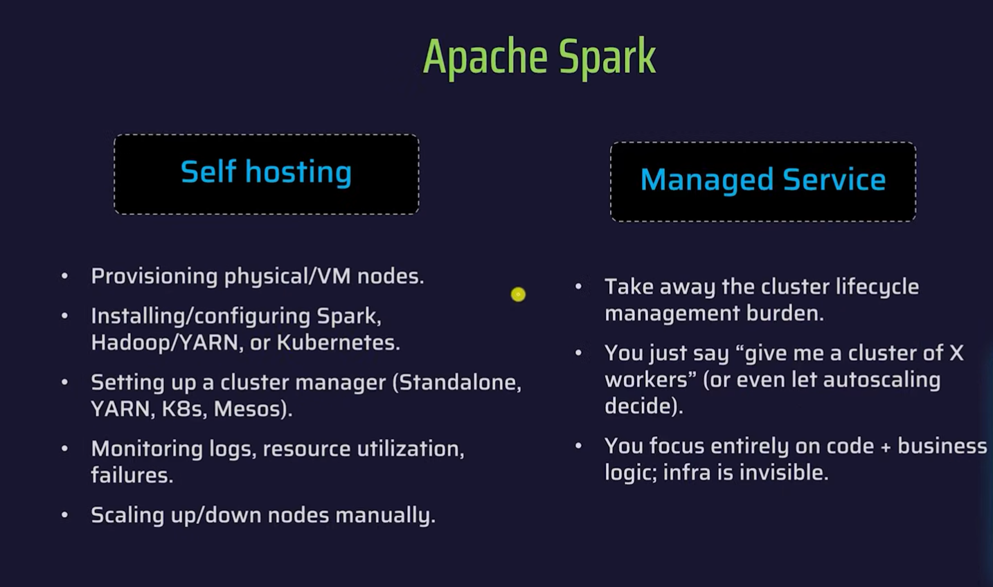

Data Engineering
18 February 2026
09:19

What is Data Engineering?
The practice of designing, building, and maintaining scalable systems and pipelines that collect, store, and process raw data into usable information
Key Components of Data Engineering
- Data Collection - gathering raw data from various sources such as databases, APIs, sensors, and logs

When you use YouTube:
- What video you watched
- How long you watched
- What you clicked next
All that gets collected.

- Data Storage - Once data is collected, it needs to be stored in a manner that allows for efficient retrieval and processing
- It is usually stored in data warehouses, data lakes, and databases
- Data Warehouses -
A Data Warehouse is like a super-organized library. Everything is cleaned and arranged properly so it is easy to search and analyse.
- Reports
- Dashboards
- Business analysis
- Data Lake -
A Data Lake is like a big storage room where you dump everything — clean or dirty — and organize it later.
- Images
- Videos
- Logs
- Raw files

- Data Processing - Transforming raw data into a structured and usable format.
- Involves data cleaning, normalization, and integration
- Tools used are Apache Spark, Hadoop
Example:
Name: john
Age: fifteen
Processing makes it:
Name: John
Age: 15

- Data Pipelines - Automated workflows that move data from source to destination, ensuring that data flows smoothly and consistently.
Source → Cleaning → Storage → Dashboard

- Data Quality and Governance - Implementing policies and procedures to maintain data accuracy, consistency and security.
Imagine if:
- Same person appears 3 times
- Wrong ages are stored
- Private data gets leaked
That’s bad.

Why is Data Engineering Important?
Without Data Engineering:
- Reports will be wrong
- AI models will fail
- Business decisions will be bad
- Data will be messy and slow
It’s like trying to cook with dirty ingredients.

Data engineering forms the backbone of any data-driven enterprise. It ensures that data is accurate, reliable, and accessible, providing a solid foundation for data analysis, machine learning, and artificial intelligence applications. Without effective data engineering, organizations may struggle with data inconsistencies, bottlenecks, and inefficiencies, hindering their ability to derive meaningful insights.

Challenges in Data Engineering
Data engineering is not without its challenges. Common issues include:
- Handling Large Volumes of Data: Managing and processing large datasets efficiently requires specialized tools and techniques.
- Ensuring Data Quality: Consistently maintaining high data quality across diverse sources can be complex.
- Scalability: Building systems that can scale with growing data volumes and user demands.
- Data Security: Protecting sensitive data from breaches and ensuring compliance with regulations.
- Keeping Up with Technology: Rapid advancements in technology require data engineers to continually update their skills and knowledge.

Types of Data Collection and their difference
24 February 2026
10:56
Below is a clean, simple, and symbol-free explanation, exactly as you requested.

Types of Data Collection and Their Differences
Data collection methods are generally categorized into two main types: Primary Data Collection and Secondary Data Collection.
Primary Data Collection
Primary data is data collected directly from the original source for a specific purpose.
Examples include:
• Surveys
• Interviews
• Observations
• Experiments
• Sensor or machine-generated data collected firsthand
Characteristics:
• Data is original and collected for a specific problem
• Usually more accurate and reliable
• Time-consuming and costly to collect

Secondary Data Collection
Secondary data is data that has already been collected, processed, or published by someone else.
Examples include:
• Company databases
• Public datasets
• Government reports
• Research papers
• Data from APIs
• Existing logs, transaction records, or historical files
Characteristics:
• Already available and easier to access
• Less expensive
• Faster to obtain
• May not be perfectly aligned with the exact problem
• Quality depends on the original source

Key Differences
Aspect | Primary Data | Secondary Data
Source | Collected directly from the original source | Collected by someone else
Cost | Higher | Lower
Time Required | More | Less
Accuracy | High, because it is original | Varies, depends on the source
Common Examples | Surveys, experiments, sensors | Databases, files, reports, APIs

Type of Data Mostly Used in Databricks
In Databricks, work is primarily done using secondary data.
This is because Databricks is designed as a large-scale data processing and analytics platform that usually deals with:
• Historical data stored in data lakes
• CSV, JSON, and Parquet files
• Databases such as SQL Server, MySQL, or PostgreSQL
• Cloud storage like Azure Data Lake or AWS S3
• Logs and operational data
• Data from APIs
Although primary data can also arrive in Databricks (for example, real-time streaming from sensors or IoT devices), it is typically processed after being collected by external systems. Therefore, in most projects, Databricks primarily handles secondary data.

